DESCRIPTION
Introduction
Bionic Greenhouse Building with a Vertical hydroponic farm, that means no soil needed to grow plants to save Money and water. We will work on the humidity which we have a lot of if we use the cool weather outside and clear it.
THE NEED:
- Currently there is limited access to electricity, water, and sustainable heating/cooking methods.
- A lack of access to lighting at night limits in-home learning.
- The artisans require the ability to communicate with international partners.
Goal:
To create a natural supermarket where people can buy Local Plants, vegetables and fruits. Which can also be a Garden with good Green Looks Views for people to visit and Walk along. To attract many people to offer them to try organic plant harvesting with natural sources that will save a lot of water and energy for years to come.
Chip:
Converting greenhouses gas emissions into energy-rich fuel using Nano silicon (Si) in a carbon neutral carbon cycle is illustrated
THE STORY:
project the “Tech Green”.
To calculate the co2 emission from the fuel consumption, 1 kg of L-gas consists for 61, 4% of carbon, or 614 grimes of carbon per kg of L-gas. In order to combust this carbon to CO2, 1638 grimes of oxygen is needed. The sum is then 614 + 1638 = 2252 grimes of CO2/kg of L-gas. An average consumption of 5 kg / 100 km then corresponds to 5 kg x 2252 g/kg = 113 gCO2/km.
Now we’ll get the energy from plants so to do so we need to convert the co2 to co methane, new catalyst can turn carbon dioxide or carbon monoxide into methane. ... The molecule uses energy from the sun to break up the CO2 molecule into carbon and oxygen atoms, which then combine with hydrogen to form methane and water.
Plant-e is one of the World Economic Forum’s 2015 class of Technology Pioneers. The company is developing technology that generates electricity from living plants without damaging them. Especially suitable for wet areas such as rice paddy fields, it could provide clean power to remote communities. Nanda Sharma, chief marketing officer, discusses its potential.
While the principle may sound straightforward, the challenge is generating useful amounts of electricity cost-effectively.
We will be using also the Vertical axis wind turbine technology continues to improve, most wind turbines fall into one of two general categories: horizontal axis and vertical axis. Each can be further divided into small and large wind turbines.There are very mature technologies
Problems with traditional designs:
Some will argue that the pain points of traditional wind turbine Industry include:
- Often a high power generation cost than traditional energy
- Manufacturing is complex
- Large parts are difficult to transport
- A foundation that requires a large volume
- Installation requires complex and costly cranes
- Noise pollution
- Damage to the ecosystem
- Chemical pollution is possible
Solution: The Super Turbine and how it works
Over ten years of R&D in the VAWT industry has led to the Super Turbine, a type of large wind turbine. The Super Turbine, developed by 2014, has low power-generation costs, and easy installation and maintenance. At its core is an extension of the “active real-time pitch attack angle regulation” technology which has been verified by experiments. We think it could lead a revolution in current large, wind-turbine industry.
- To produce power, hundreds of blades are moved along a track by lift forces and transmitted through a chain to drive hundreds of generators fixed on the circular track.
- Active real-time pitch angle regulation technology monitors the wind direction, speed, and the position of each blade on the track. Then it adjusts the blades’ angles to gain the maximum lifting force.
- A single Super Turbine can be designed to fit a wind farm’s conditions and customer requirements. A turbine can be sized from 7 to 50 MW.
The forces and the velocities acting in a Darrius turbine are depicted. The resultant velocity vector, {\display style {\vex {W}}} {\vex {W}}, is the sectorial sum of the undisturbed upstream air velocity, {\display style {\vex {U} {\vex {U}, and the velocity vector of the advancing blade, {\display style - {\vex {\omega}}\times {\vex {R}}} - {\vex {\omega}}\times {\vex {R}.

Solar panel (PV cell):
Photovoltaics as a method for generating electric power by using solar cells to convert energy from the sun into a flow of electrons by the photovoltaic effect. Solar cells produce direct current electricity from sunlight which also can be used to power equipment or to recharge a full battery.
Similar to:
Also the project will include water harvester to reduce the use of water and get usefull from the humidity:
The United Arab Emirates is classified among the categories of countries with highest rate of vulnerability to the potential impacts of climate change in the world. This will result in warmer weather, less precipitation, droughts, higher sea levels and many more storms.

The material we will be using:
Inflatable fabrics are typically coated or laminated with synthetic materials to increase their strength and environmental resistance. Among the most widely used materials are polyvinyl chloride (PVC) coated vinyl or nylon, and oxford woven cloth. PVC coated materials are more durable and more expensive. Inflatable fabrics are typically coated or laminated with synthetic materials to increase their strength and environmental resistance. Among the most widely used materials are polyvinyl chloride (PVC) coated vinyl or nylon, and oxford woven cloth. PVC coated materials are more durable and more expensive.

The consequences of these impacts are intense on infrastructure, human health and natural habitat, which affect various development sectors and policies including socio-economic, health and environment.
On the other hand, the economic boom and population growth increase the demand on energy, water and natural resources, which indirectly contribute to the levels of carbon dioxide emissions and climate change in general.
The UAE plays a central role in the world’s energy economy as a supplier of fossil fuels, which gives the country an important stake in finding solutions to cutting emissions while still providing the world with the energy it needs.
The UAE weather is so hot so we thought we can use wind turbans, designed as an alternative to fossil fuels, still contribute to climate change due to the way they redistribute heat and moisture in the atmosphere, according to a study published Thursday.
Researchers from Harvard University found that powering the entire United States with wind energy would cause a 0.54 degree Celsius ground temperature rise in the area where the turbines were located, and a 0.24C increase across the continental United States.
"Wind beats coal by any environmental measure, but that doesn't mean that its impacts are negligible," said David Keith, an engineering and public policy professor and senior author of the study, published in Joule.
Solar power in the UAE has the potential to provide most of the country's electricity demand. ... However, solar power still accounts for a small share of energy production in the country. Until 2013, there wasn’t operational solar power in theUae.

Estimated Cost: 100000$
19 per watt x4800 total watt =91200 kWh total

WEATHER IMPACT
The UAE is classified among the categories of countries with highest rate of vulnerability to the potential impacts of climate change in the world. This will result in warmer weather, less precipitation, droughts, higher sea levels and more storms.
The consequences of these impacts are intense on infrastructure, human health and natural habitat, which affect various development sectors and policies including socio-economic, health and environment.
On the other hand, the economic boom and population growth increase the demand on energy, water and natural resources, which indirectly contribute to the levels of carbon dioxide emissions and climate change in general.
The UAE plays a central role in the world’s energy economy as a supplier of fossil fuels, which gives the country an important stake in finding solutions to cutting emissions while still providing the world with the energy it needs.
The UAE weather is so hot so we thought we can use wind turbans , designed as an alternative to fossil fuels, still contribute to climate change due to the way they redistribute heat and moisture in the atmosphere, according to a study published Thursday.
Researchers from Harvard University found that powering the entire United States with wind energy would cause a 0.54 degree Celsius ground temperature rise in the area where the turbines were located, and a 0.24C increase across the continental United States.

Technology:

Future prediction and Goal

TECHNOLOGY
Elica Idroponica concept
Elica Idoponica is a concept for a full hydroponic system that combines irrigation, lighting and automatic dosing.
To solve the problems of most homeowners who don’t remember to water their plants or place them in sunlight, industrial designer Stefania Minnella has come up with a concept hydroponic planter that makes you grow healthy plants with all care
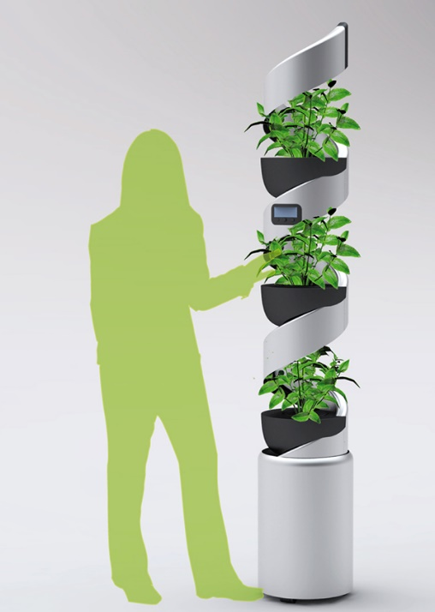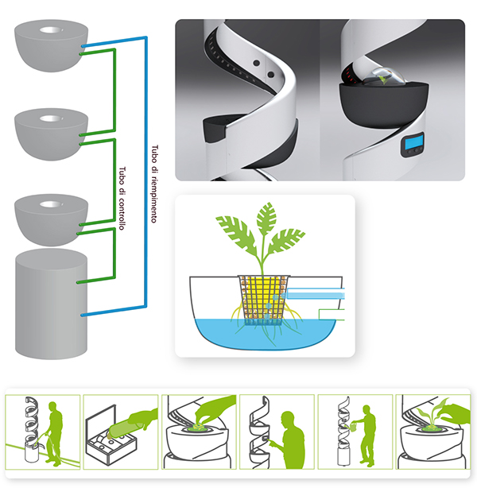

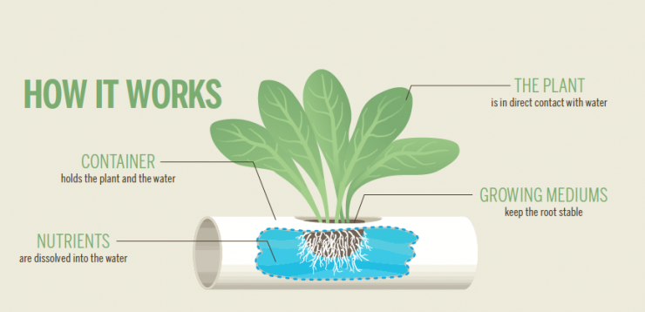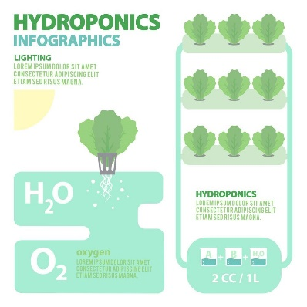
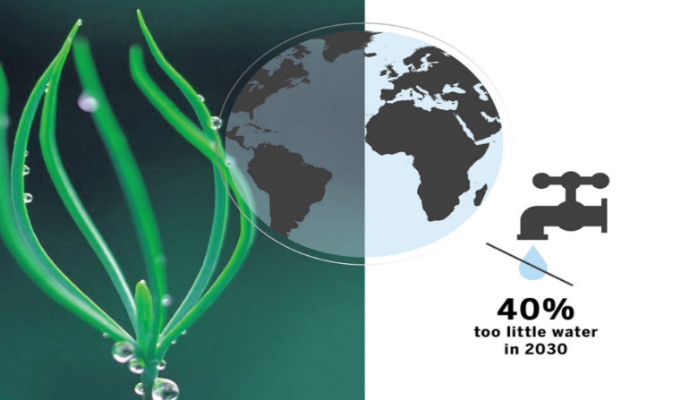
Aero is a water humidity harvester created for urban gardening communities. With innovative technology it absorbs water molecules passively with polymer coated cotton membranes. Twisting motions are applied to harvest up to 200L of water per day to be shared. The cotton with PNIPAAm can store water up to 350% of its w 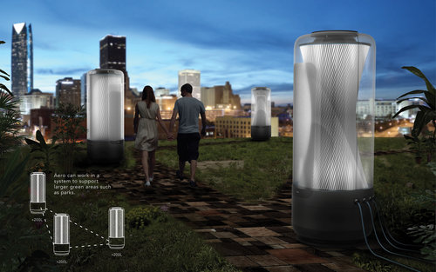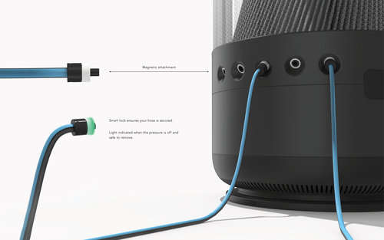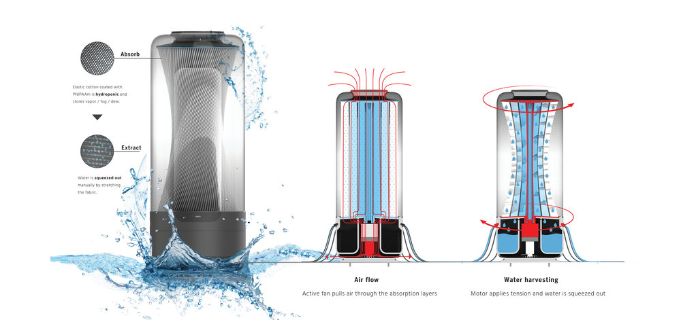

CALCULATION
The kilowatt is a unit pf power. It is equal to 1000 watts and equivalent to 1000 Joules per second. The kilowatt (kW) is equal to one thousand (103) watts. This unit is typically used to express the output power of engines and the power of electric motors, tools, machines, and heaters.
The kilowatt hour is a composite unit of energy equivalent to one kilowatt (1 kW) of power sustained for one hour. One watt is equal to 1 J/s. One kilowatt hour is 3.6 mega joules, which is the amount of energy converted if work is done at an average rate of one thousand watts .

Dimension:
We’ll be using 10 VAWT’s in Rotor. For this estimate we have assumed a figure of 5.7
M/s for annual wind speed (is the average from the data from St Kilda Harbor wind data supplied by LAGI
200w x 24hours = 4800 watt hours/day or 4.8kWh/day
10kwh day x 365 days = 9.80895744 × 1019 m2 kg per year

TECHNOLOGY USED
1. Photovoltaic technology, output energy 45% which is very efficient way to generate energy.
2. Water harvesting from humidity __to save 100 to 200 liters per tank
4.Capture CO2 convert to CO __ converting grass can be a good energy generate as the Masdar is CO2 free that means it is impossible to crop in the city but with Vertical farm convert to bio energies it may be.

